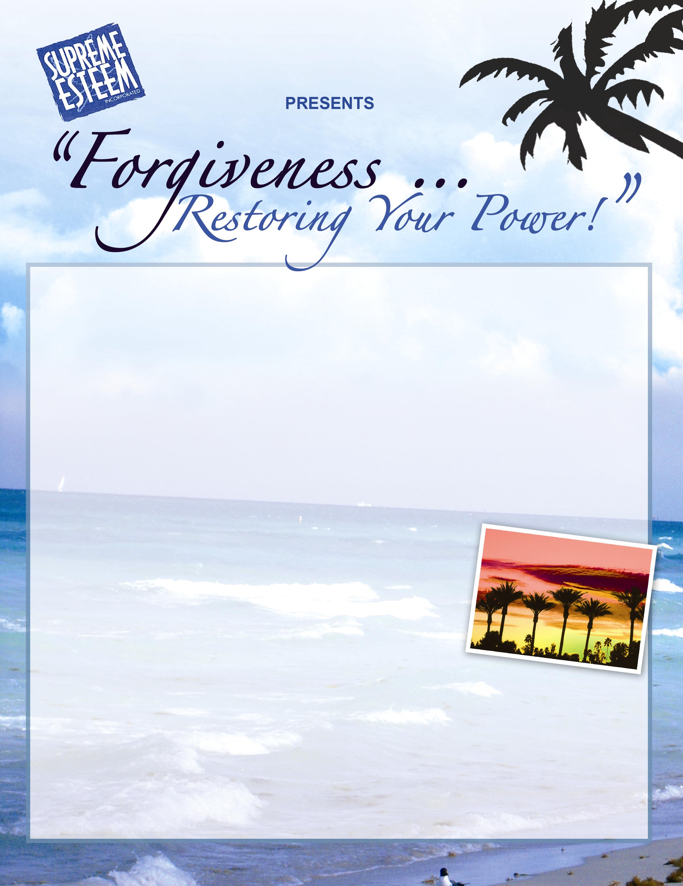

Relish the ultimate in FORGIVENESS, EMPOWERMENT, and ENJOYMENT as author, counselor, producer, speaker, and teacher extraordinaire, Ms. Jacqueline Hazél, President of Supreme Esteem, Inc. leads you through an unforgettable experience!

Every time we hold a grudge, or play the victim role, we have given our power away to situations involving people, places, and organizations. Forgiveness is for your sake and not for the other person’s sake. TAKE YOUR POWER BACK, NOW! Learn why, what, and how to forgive.

Spread the Word! You Will Never Be The Same Again!

Join us in the Dominican Republic, April 1 – 6, 2008, for all-inclusive accommodations at the fabulous RIU PALACE PUNTA CANA! For the discounted price of $1,500, enjoy a double occupancy junior suite, meals, airfare from Miami, workshops, workshop materials, and one individual session (optional). For more information about the Riu Palace Punta Cana, log on to www.riu.com. Reserve your space today!

PAYMENT PLAN
A non-refundable deposit of $350 is due by October 21, 2007.
An additional $400 is due by November 21, 2007.
Another $400 is due by December 21, 2007.
The balance of $350 is due by January 21, 2008.
(NOTE: NO REFUNDS AFTER DECEMBER 15, 2007)

-------------------------------------------------------------------------------------------------------------------------------------------------------------
PLEASE PRINT REGISTRATION INFORMATION:

Last Name __________________________________First Name________________________________ M.I.______
Address___________________________________City__________________________ST______ZIP____________
Home Phone#_________________________ Work #_______________________Cell #_______________________
E-Mail Address_______________________________________
Roommate _________________________________Special Needs________________________________________
Make money orders payable to: Supreme Esteem, Inc., P.O. Box 823451, South Florida, FL 33082
For credit card payment check here _____, and then register on line at www.supremeesteem.com.
Credit card payments will incur a processing fee of 2.9% + $0.30
Contact SUPREME ESTEEM HEADQUARTERS at: 954-392-3762 (o), 954-392-3760 (f), j_hazel@bellsouth.net

